Title: PAD Remote Reset Function
for MTRC TCL and URL K Train

Date of issue: | May 25th, 2025
Reference: | N/A
Report #: | TVHS6098, Rev.6

Project Customer | MTRC  TKE and URL | Project identification | PA
Component description | N/A | Tech. Specification / drawing no. | N/A
Supplier name | TOA ENGINEERING | Serial Number of Report | -
Supplier Manufacturing Site | Japan

Prepared: | D. Tanaka  SIGNATURE | 07/19/2024  DATE
Verified: | D. Tanaka  SIGNATURE | 07/19/2024  DATE
Approved: | S. Asano  SIGNATURE | 07/19/2024  DATE

- Introduction
This document is a proposal for remote reset function for the existing MTRC broadcast equipment emergency calls.
- The existing emergency call handle is a lock type, and it is unlocked without a key. This device will provide a reset signal to the latch-type emergency call handle to be provided by the MTR to release the call remotely.
- This is to make one additional dry contact when emergency calls are available on the train.
- The target Safety Integration Level（SIL） is “0”.

- Proposal for Remote Reset Function for PAD (Passenger Alarm Device)
  - Overview
Existing power amplifiers and PADs do not have the ability to reset control. Therefore, one reset device will be added to each vehicle to monitor and reset the PAEHs (emergency call status).

<Block Diagram>
DC77 ~ DC137.7

110E
110E
DC77 ~ DC137.7
Add Unit1
Existing PAMP ＆ RSC
Provided from Customer

- Add equipment to monitor existing communication lines (Read Only)
- The handle release is performed by “reset trigger” from DVAU.
- Wiring between power amplifier <=> emergency call (RSC): Same as existing, no change.
- Wiring between emergency call (RSC) <=> emergency handle (PAEH): Same as existing, no change.

- Specification of the voltage output control
These contacts will work around one second for output of the DC12V, when detected the MCP or the TMS communication is finished.

Specification |  | Note
Relay type | Solid state relay | Normal Open
Output Voltage | DC12V
Output pulse time | 1sec < output < 2sec
Maximum Currect | 50mA (MAX) / Each Contact | Total Maximum 250mA

  - Modification/Change Points
- One unit will be added to each vehicle.
- Additional wiring is required in the vehicle for the additional unit.
- The existing communication format will be changed between DVAU and TMS to make additional bits for make a reset trigger.
- The existing PA system communication of format will be changed to make an additional command for reset trigger.
Only DVAU needs to be changed. The PAMP and others need no modifications.

  - Verification Work
- Activate the PAEH.
- Select the activating PAEH by the MCP or the TMS.
- Make sure the activated PAEH can be released after being operated on the MCP or the TMS.

NOTE:
TOAE expects that there is time lag after acknowledging the PAEH activation by the MCP or TMS until the PAEH is reset remotely. The time lag should be verified in the vehicle.
If it's necessary to mask the time lag, it will be adjusted by DVAU software.
The quotation is not included for this proposal.

  - Outline Drawing

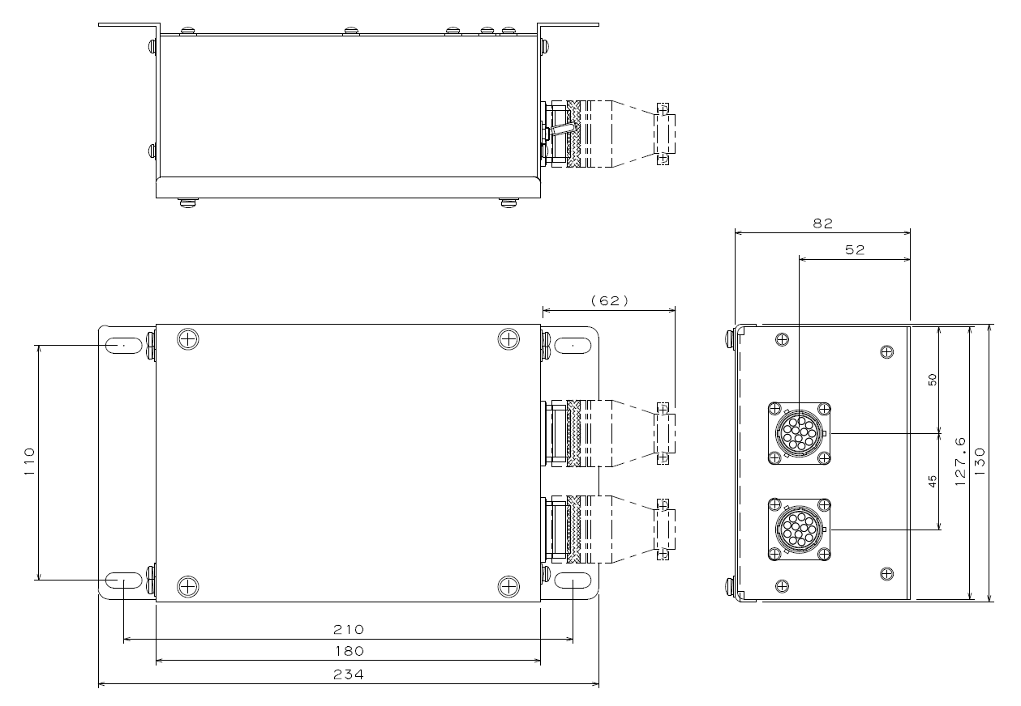

- Proposal for Making One Additional Unit for Dry Contact
  - Overview
The DVAU is difficult to make an additional dry contact by modification. Therefore, we will propose the additional dry contact control unit.
The unit checks the RS485 train communication line and controls the contact. This unit is installed to DM car and works at the same time.

<Block diagram>
110E
DC77 ~ DC137.7
The contact is located in the Add Unit2
To Other System
Add Unit2
Existing DVAU & MCP
- Add equipment to monitor existing communication lines (Read Only)
- The unit is installed to both DM cars and working at the same time.
- The contact is normally closed.
- The contact will be open condition when a PAEH is activated.
- When the PAEH is acknowledged by MCP/TMS, the contact has become normal.
- The Bypass SW function is to make a normal condition manually in case fault condition of each contact due to any reasons.
- The dry contact specification is as follows.

Specification |  | Note
Relay type | Solid state relay | Normal Closed
Maximum Voltage | DC150V (MAX)
Maximum Currect | 200mA (MAX)

  - Modification/Change Points
- One unit will be added to DM car.
- Additional wiring is required in the vehicle for the additional unit.

  - Verification Work
- Check the dry contact before the PAEH is activated.
(Normal Closed condition)
- Activate the PAEH.
- Check the dry contact is activated for other system.
(The contact is open condition)
- Select the activating PAEH by the MCP or the TMS.
- Check the dry contact.
(The contact becomes normal closed condition)
- Hold the communication for the PAEH.
- Check the dry contact is activated for other system.
(The contact keeps in normal closed condition)
- Select the activating PAEH by the MCP or the TMS.
- Check the dry contact.
(The contact becomes normal closed condition)
- Make sure the activated PAEH can be released after being operated on the MCP or the TMS.
- Check the dry contact after all PAEHs are released.
(The contact keeps in normal closed condition)
  - Outline Drawing

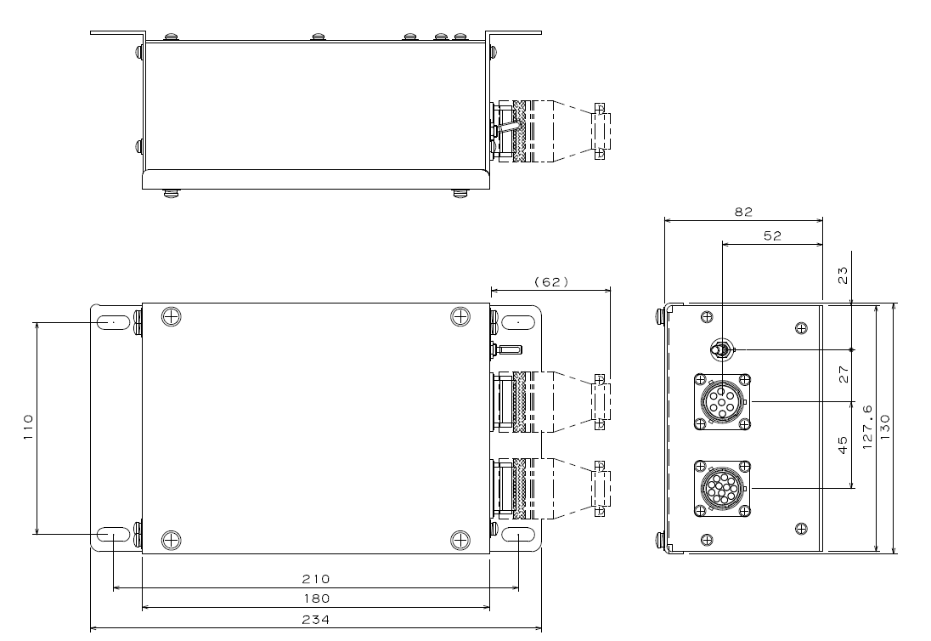

- Proposal for Control Method between TMS and DVAU
  - Overview
We have checked the existing interface documents between TMS and DVAU.
（MELCO document number: JHAM552）
The SDR is included in the following bits.
And PS requested additional command for PAD reset function.
(URL and TKE K-trains are same interface: PS1060)

SDR (From TMS)
- Talk back Selection bits (Existing Interface)
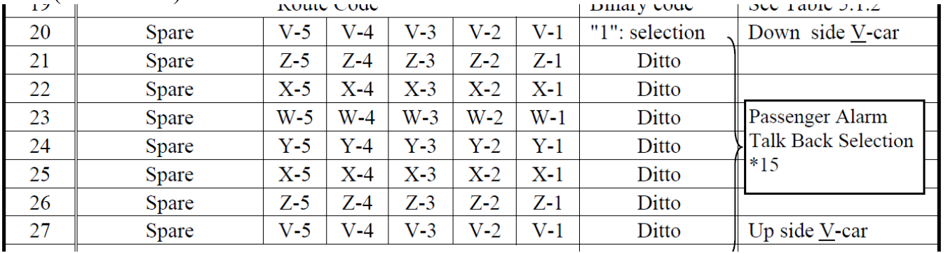

- PAD reset Selection bits (Additional Interface from PS)
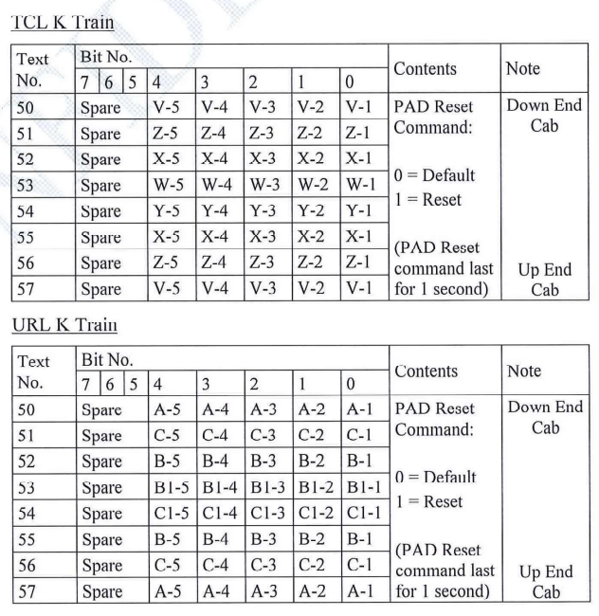
We have considered to use those bits to make remote reset control.
The proposal logic is the following status.

STEP 1)
One of PAEH is activated, and the DVAU sends the target PAEH device bit. (Set to “1”)
STEP 2)
TMS operated the existing interface to set the talk back bit to target device.
(Set to “1”).
Communicate with passenger.
STEP 3)
Completed the communicate with passenger.

STEP 4)
TMS set the PAD reset bit. (Set to “1”)
The PA system check this bit.
After detecting it, the remote reset unit will start the reset function to target device.

This sequence will keep the existing function and make the additional PAD reset bits therefore, it does not affect to the existing interface between TMS and DVAU.

- Logic for PAD Reset Control by TMS on Each Cars and Dry Contact on DM Cars

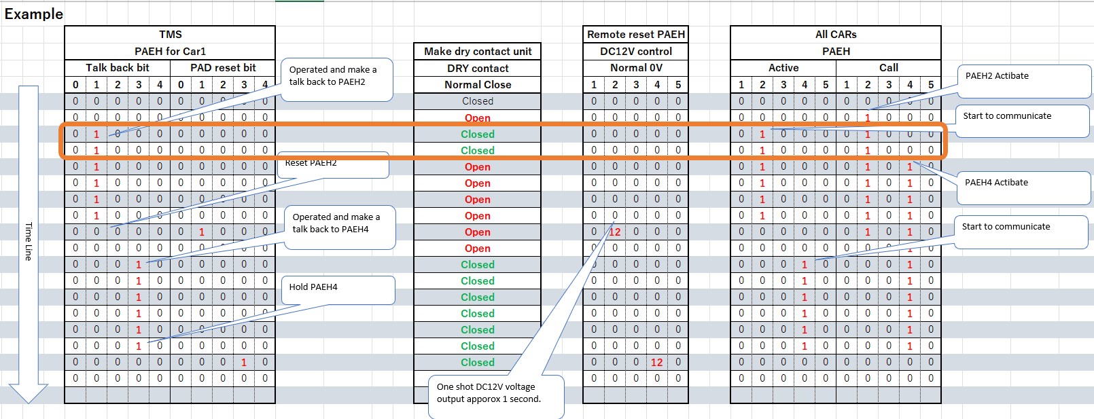

- Proposal for Control Method Operated by MCP
  - Overview
The Function MCP is controlled by DVAU software.
The MCP will report the operating action to master DVAU.
TOAE will support the following operation to make a PAD reset function.

STEP 1)
One of PAEH is activated, and the DVAU sends the PAD status to MCP.
MCP displays the PAD call situation.
STEP 2-1)
A driver operates the MCP, selects the target PAD, and pushes the “ENT” button to start communication with passenger.
If the driver needs to hold the communication after completing the communication,
they should select the “ENT” one more time, then the PAD call status will be kept as same as the existing function.
Whole trains PA is available PAD communication with passenger will be enabled again after pressing “ENT”.
STEP 2-2)
A driver operates the MCP, selects the target PAD, and pushes the “ENT” button to start communication with passenger.
If the driver needs to reset after completing the communication, they should select the “RST” button, and the remote reset unit will start the reset function to target device.

Note1: Under selected PADs (Hold or not answered) and press the “RST” cannot be reset.
Note2: Remote reset PAD function can be carried out one-by-one.

- Proposal for Waiver of Electromagnetic Compatibility
The control unit would be an auxiliary component of existing components such as the DVAU and PAMP. The design of the control unit is based on the design of the existing components.
Therefore, TOAE understands that this control unit has no impact on the EN50121-3-1 and EN50121-3-2 which is required in section 4.5 of PS.
TOAE will submit the detailed design information to MTR, so we would like to propose the waiver of this kind of qualification test for this component.

--- End of Document ---

